***Mobile Application Development Lab***

***CSL-341***

# Lab Journal



**Student Name: ABDUL WASAY**

**Enrollment No: 01-134222-006**

**Class and Section: BSCS-6B**

**GITHUB LINK:** https://github.com/AbdulWassay21/MadLab-Wassay

**Department of Computer Science**

## BAHRIA UNIVERSITY ISLAMABAD

Tasks

**1.** Create a simple application with following functionality:

1. Background color white
2. Add an App bar with ‘blue Accent’ background color
3. Give a title to that App bar of ‘White’ color

### Code

|  |
| --- |
| import 'package:flutter/material.dart'; import 'package:flutter/services.dart';    void main() {  WidgetsFlutterBinding.ensureInitialized();  SystemChrome.setPreferredOrientations([  DeviceOrientation.portraitUp,  DeviceOrientation.portraitDown,  ]).then((_) {  runApp(const MyApp()); });}    class MyApp extends StatelessWidget { const MyApp({super.key});    @override  Widget build(BuildContext context) { return MaterialApp( title: 'Simple Flutter App', theme: ThemeData(  primarySwatch: Colors.blue,  ),  home: const MyHomePage(), ); }}    class MyHomePage extends StatelessWidget { const MyHomePage({super.key});    @override  Widget build(BuildContext context) { return Scaffold( appBar: AppBar( backgroundColor: Colors.blueAccent, // Blue Accent App Bar title: const Text( 'White Title',  style: TextStyle(color: Colors.white), // White color for the title ),), |

body: Container( color: Colors.white, // White background child: const Center( child: Text( 'Hello, Flutter!',

style: TextStyle(fontSize: 24),

), ),

),

);}}

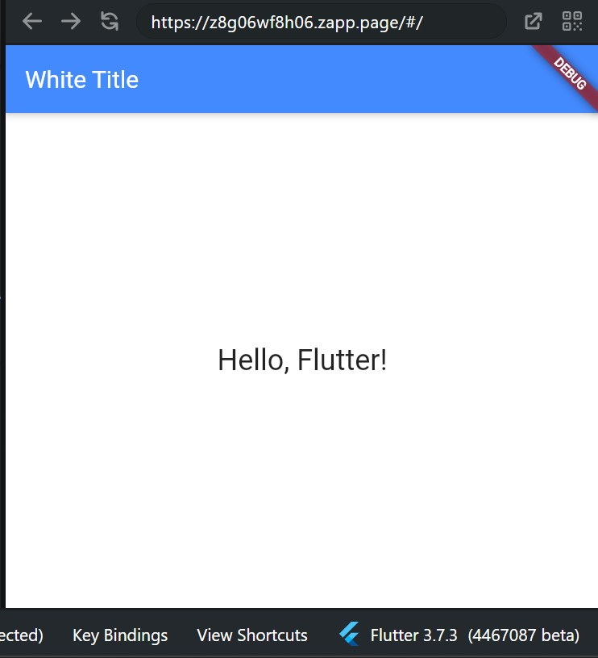

2.Introduce yourself and add it in your application. Your application includes:

1. One paragraph of your introduction
2. Your name should be bold (use bold property of text)
3. Your qualities should be slanted (use italic property of text)
4. Paragraph should be in center of the screen

|  |
| --- |
| import 'package:flutter/material.dart';    void main() { runApp(const MyApp()); }    class MyApp extends StatelessWidget { const MyApp({super.key});    @override  Widget build(BuildContext context) { return MaterialApp( title: 'My Introduction', theme: ThemeData(primarySwatch: Colors.blue), home: Scaffold( appBar: AppBar( backgroundColor: Colors.blueAccent, title: const Text( 'Introduction',  style: TextStyle(color: Colors.white),  ), ),  body: Center( child: Padding( padding: EdgeInsets.all(16.0), child: RichText( textAlign: TextAlign.center, text: TextSpan( style: TextStyle(fontSize: 20, color: Colors.black, height:  1.5),  children: [  TextSpan(text: 'Hello! My name is '), TextSpan(  text: 'ABDUL WASAY', style: TextStyle(fontWeight: FontWeight.bold), // Bold Name  ), TextSpan(  text: '. I am in 6th semester in bs computer science bahira university '  'I have experience in ' |
| 'graphic designing, and I am learning Flutter . '  'I am ',  ), TextSpan(  text: 'passionate about ', style: TextStyle(fontStyle: FontStyle.italic), // Italic  Qualities  ), TextSpan(  text: ' flutter development .',  ),  ],  ),  ),  ),  ),  ),  );  } } |

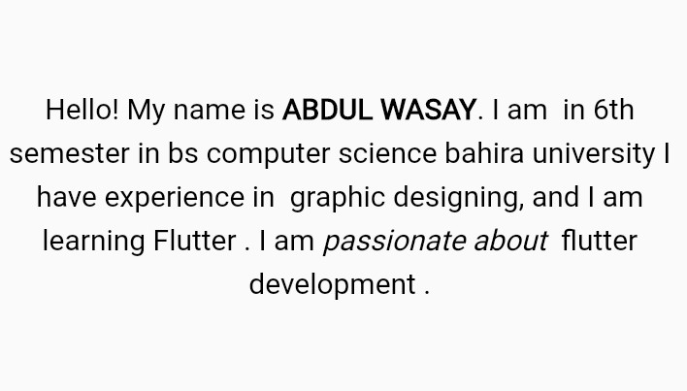

3.Add a star icon with your paragraph

|  |
| --- |
| import 'package:flutter/material.dart';    void main() {  runApp(const MyApp());  }  class MyApp extends StatelessWidget { const MyApp({super.key});    @override  Widget build(BuildContext context) { return MaterialApp( title: 'My Introduction', theme: ThemeData(primarySwatch: Colors.blue), home: Scaffold( appBar: AppBar( backgroundColor: Colors.blueAccent, title: const Text( 'Introduction',  style: TextStyle(color: Colors.white),  ), ),  body: Center( child: Padding( padding: const EdgeInsets.all(16.0), child: Column( mainAxisAlignment: MainAxisAlignment.center, children: [ // 🌟 Star Icon const Icon( Icons.star,  color: Colors.yellow, size: 50,  ), |
| const SizedBox(height: 20), // Spacing between icon and text RichText(  textAlign: TextAlign.center, text: TextSpan( style: TextStyle( fontSize: 20, color: Colors.black, height:  1.5),  children: [  TextSpan(text: ' My name is '), TextSpan(  text: 'ABDUL WASAY', style: TextStyle( fontWeight: FontWeight.bold), // Bold Name  ), TextSpan( tex t:  '. I am in 6th semester in bs computer science bahira university '  'I have experience in '  'graphic designing and I am learning Flutter. '  'I am ',  ), TextSpan(  text: 'passionate about flutter development', style: TextStyle( fontStyle: FontStyle.italic), // Italic Qualities  ), TextSpan( text: ' .',  ),  ],  ),  ),  ],  ),  ),  ),  ),  );  } } |

